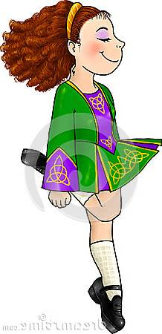 GET REEL 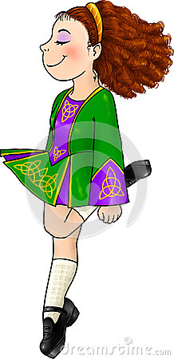
Artist: Urban Trad Album: Kerua
Level: Intermediate May 2019 Available for download on iTunes
Choreo: Andy Howard (Americanracket@gmail.com) & Darolyn Pchajek (Darolyn@daretoclog.com)
Wait 32 beats

PART A
Waterloo (turn ¼ left)
Eric (turn ¼ left)
Repeat both steps to front

PART B
Kentucky Yeti (move forward)
Mario (turn ½ right)
Repeat both steps to front

PART A
Waterloo (turn ¼ left)
Eric (turn ¼ left)
Repeat both steps to front

PART B
Kentucky Yeti (move forward)
Mario (turn ½ right)
Repeat both steps to front

PART C
Suzy Step (moving left)
Urban Step
Repeat both steps with opposite footwork

PART C
Suzy Step (moving left)
Urban Step
Repeat both steps with opposite footwork

PART C
Suzy Step (moving left)
Urban Step
Repeat both steps with opposite footwork
DISCO
Rocking Chair
Brasstown
Karate Rock (turn ½ right)
Repeat all steps to the front

PART E
Show Off
Simone
Rooster Run
Rock Double (turn ½ left)
Repeat last 2 steps to front

PART F
2 Josepi’s

PART E
Show Off
Simone
Rooster Run
Rock Double (turn ½ left)
Repeat last 2 steps to front

PART F
2 Josepi’s

PART E
Show Off
Simone
Rooster Run
Rock Double (turn ½ left)
Repeat last 2 steps to front

PART F
2 Josepi’s

PART F
2 Josepi’s

STEPS TO “Get Reel”

Waterloo DS RS(f) RS(os) Heel(f) Toe(b) Heel/Ball Chug/Slide RS DS Drag/Kick Step
(turn ¼ left on Toe(b)) L RL RL R R L / R L / R LR L L / R R
&1 &2 &3 & 4 & 5 &6 &7 & 8

Eric DS DT(os) Rock Heel(w) RS Rock Heel(w) RS DS RS
(turn ¼ left on DT(os)) L R R L RL R L RL R LR

Kentucky Yeti DS Drag Step DS Slide RS Slide RS DS RS
L L R L L RL L RL R LR

Mario DS RS(os) Hop/Clap Step(xf) RS(os) Flap Step(xb) RS Hop/Clap Step RS
(turn ½ right on 3rd RS) L RL L R LR L L RL L R LR
&1 &2 & 3 &4 & 5 &6 & 7 &8

Suzy Step DS DT(os) Toe Heel DT(os) DS Slide Step DS RS
L R R R L L L R L RL

Urban Step DS Heel Twist(w) Step RS Heel Twist(w) Step RS DS RS Heel Twist(w) Step R L R LR L R LR L RL R L

Rocking Chair DS Brush Up DS RS
L R R LR

Brasstown DS RS(f) RS(os) Bounce Heel/Ball Chug/Slide RS DS Brush Up
L RL RL BOTH L / R L / R LR L R
&1 &2 &3 4 & 5 &6 &7 &8

Karate Rock DS Kick RS Kick
(turn ½ right on 1st kick) R L LR L

Show Off DS RS Leg Swing(xf) Swing(os) Swing(xf) Swing(os) RS Ball Slide DS RS
L RL R R R R RL R R L RL

Simone DT(b) Brush Up Tch(xf) Tch(xf) Tch(os) Tch(xf) DS RS
R R R R R R R LR

Rooster Run DS DS(xf) Ball(os) Ball(xb) Ball(os) Ball(xf)
L R L R L R

Rock Double RS DS DS RS
(turn ½ left on 1st RS) LR L R LR

Josepi DS Brush Up DT Ball Ball(xb) Ball Ball(os) Ball(xb) Ball Step(os) DS RS
L R R R L R L R L R L RL

