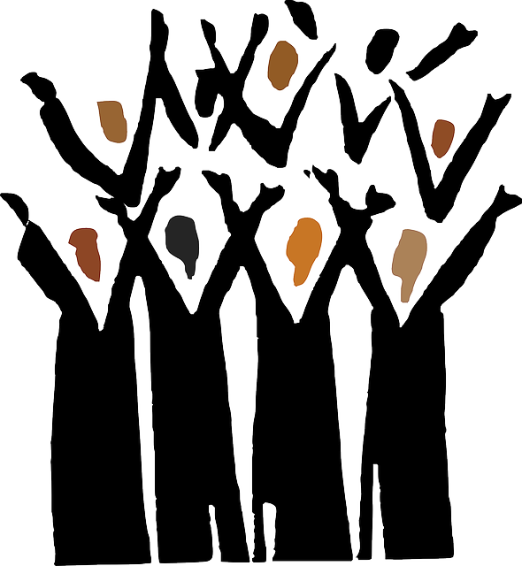 HALLELUJAH BABY
Artist: Rosie & the Riveters CD: Good Clean Fun! Song available on iTunes
Choreo: Darolyn Pchajek, Darolyn@daretoclog.com 147 Charing Cross Cres., Winnipeg, MB R2N 1N6 Canada
Wait 16 beats Level: Beginner’s Plus

PART A
Rocking Chair DS Brush Up (turn ¼ left) DS RS
(turn ¼ left) L R R LR

Double Basic with a Clap DS DS RS Clap
L R LR

-Repeat 3 more times to front-

PART B
Travelling Shoes DS Heel Twist Step Heel Twist Step Heel Twist Step
(turning ¼ left) L R L R L R L

Triple DS DS DS RS
R L R LR
-Repeat both steps 2 more times-

Rocking Chair (turn ¼ left to front)

Double Basic with a Clap

PART B* Travelling Shoes (turn ¼ left), Triple; Repeat both steps 2 more times;
Rocking Chair (turn ¼ left), Double Basic with a Clap, Rocking Chair, Double Basic with a Clap

Part C
2 Triple Kicks DS DS DS Kick DS DS DS Kick
L R L R R L R L

2 Kicks DS Kick DS Kick
L R R L

Basic DS RS
L RL

DS & Pause DS Pause
R

INSTRUMENTAL
Kentucky Drag Loop Chain DS Drag Step(xf) DS Loop Step(xb) DS RS RS RS
(moving left) L L R L R R L RL RL RL

-Repeat with opposite footwork-

PART B* Travelling Shoes (turn ¼ left), Triple; Repeat both steps 2 more times;
Rocking Chair (turn ¼ left), Double Basic with a Clap, Rocking Chair, Double Basic with a Clap

PART C* 2 Triple Kicks, 2 Kicks, Basic (turn ¼ left), DS & Pause; Repeat last 2 steps 3 more times

PART B* Travelling Shoes (turn ¼ left), Triple; Repeat both steps 2 more times;
Rocking Chair (turn ¼ left), Double Basic with a Clap, Rocking Chair, Double Basic with a Clap

PART C** 2 Triple Kicks, 2 Kicks, Basic (turn ¼ left), DS & Pause;
2 Triple Kicks, 2 Kicks, Basic (turn ¼ left), DS & Pause; Repeat last 2 steps 2 more times

