 SUCKER 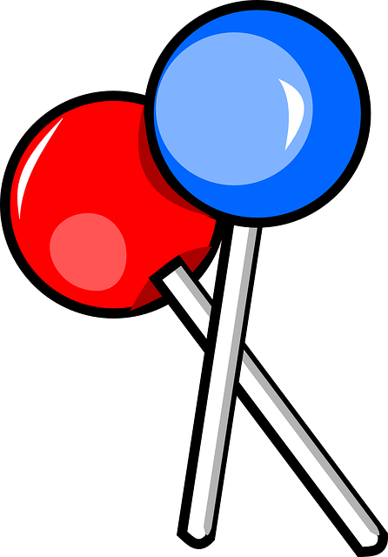
Artist: Jonas Brothers Album: Sucker – Single
Level: Intermediate Plus April 2019 Available for download on iTunes
Choreography: Darolyn Pchajek – darolyn@daretoclog.com Canada www.daretoclog.com
Start immediately after “We go”

PART A
2 Double Clicks
Over the Log
2 Unclogs (turn ¼ left)
Double Basic & a Pause (turn ¼ left)
Repeat both steps to front

PART B
Tantrum (to left corner)
2 Sway Basics
Toe Heel Rock & Clap
Repeat all steps with opposite footwork to right corner

PART C
Jonas (aka Turkey Plus Rock Brush Basic)
Kozi Strut
Repeat all steps with opposite footwork

PART D
Macnamara Pull
2 Basketball Turns (turn ¼ left each)
Triple
Repeat all steps to front

BREAK
8-count Roundout

PART A
2 Double Clicks
Over the Log
2 Unclogs (turn ¼ left)
Double Basic & a Pause (turn ¼ left)
Repeat both steps to front

PART B
Tantrum (to left corner)
2 Sway Basics
Toe Heel Rock & Clap
Repeat all steps with opposite footwork to right corner

PART C
Jonas (aka Turkey Plus Rock Brush Basic)
Kozi Strut
Repeat all steps with opposite footwork

PART D
Macnamara Pull
2 Basketball Turns (turn ¼ left each)
Triple
Repeat all steps to front

BREAK*
8-count Roundout
2 Slur Brushes (turn ½ left on first one)
Repeat both steps to front

PART B
Tantrum (to left corner)
2 Sway Basics
Toe Heel Rock & Clap
Repeat all steps with opposite footwork to right corner

PART C
Jonas (aka Turkey Plus Rock Brush Basic)
Kozi Strut
Repeat all steps with opposite footwork

PART D
Macnamara Pull
2 Basketball Turns (turn ¼ left each)
Triple
Repeat all steps to front

ENDING
8-count Roundout
2 Slur Brushes
Step

STEPS TO “Sucker”

2 Double Clicks DS Click Heel DS Click Heel
L L R R
&1 2 &3 4

Over the Log DS(f) DS(f) Step(b) Step(b) Clap
L R L R

2 Unclogs Stamp Stomp Skuff Up Stamp Stomp Skuff Up
L L R R R L

Double Basic & a Pause DS DS RS Pause
L R LR

Tantrum DS Skuff Up Stamp Stomp Tap(b) Step Stamp Stomp Tap(b) Step Kick(xf) Kick(os)
L R R R L L R R L L R R
&1 & 2 & 3 & 4 & 5 & 6 7 8

2 Sway Basics DS(xb) RS(os) DS(xb) RS(os)
R LR L RL

Toe Heel Rock & Clap Toe Heel Toe Heel RS Clap
R R L L RL

Jonas Heel Snap Ball Ball Heel Snap Step RS Brush Up DS RS
(aka Turkey Plus Rock Brush Basic) L L R L R R L RL R R LR
1 & 2 & 3 & 4 &5 &6 &7 &8

Kozi Strut DS Skuff Up Flap(b) Step Tap(b) Slide Skuff Up Flap(b) Step Tap(b) Slide Skuff Up
L R R R L R L L L R L R
&1 & 2 & 3 & 4 & 5 & 6 & 7 & 8

Macnamara Pull Heel Ball Ball(xb) Ball(os) Heel Ball Ball(xb) Ball(os) Heel(w) Pull(f) Step DS RS
L L R L R R L L L R R L RL
1 & 2 & 3 & 4 & 5 & 6 &7 &8

2 Basketball Turns Pivot (turn ¼ left) Step Pivot (turn ¼ left) Step
R L R L

Triple DS DS DS RS
R L R LR

8-count Roundout DS Toe(xf) Heel Toe Heel Toe (os) Heel Toe(xf) Heel Toe Heel Toe(os) Heel Toe(os) Heel
L R R L L R R L L R R L L R R

2 Slur Brushes DS Slur Step(xb) DS Brush Up DS Slur Step(xb) DS Brush Up
(turn ½ left on L R R L R R L L R L
first Brush when turning)

